Bright Lights Big City: Jimmy Reed
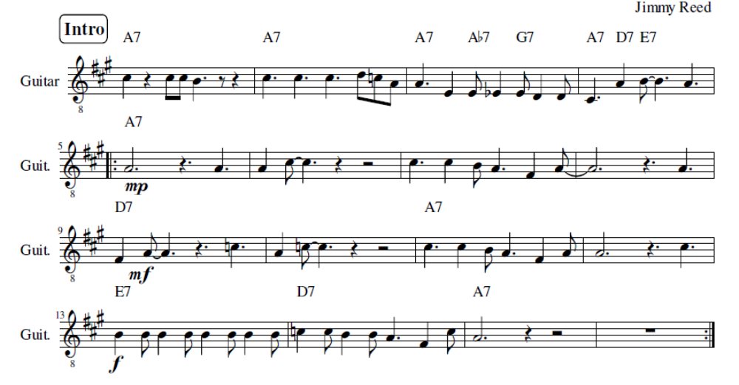

A
Bright lights, big city, Gone to my baby's head
D7 A
oh… Bright lights, big city, Gone to my baby's head
E7 D7 A
I'd tried to tell the woman, But she don't believe a word I said

E7 A
All right pretty baby... Gonna need my help some day
D7 A
oh… It's all right, pretty baby... Gonna need my help some day
E7 D7 A
You're gonna wish you had‘da listened, To some of those things I said

Harmonica SOLO
Intro with Harp, Guitar like Verse
E7 |A | |
| | |D7 | |A |
| |E7 |D7 |A | E7 |

A
Go ahead pretty baby, honey knock yourself out
D7 A
oh… Go ahead pretty baby, honey knock yourself out
E7 D7 A
I still love you baby, Cause you don't know what it's all about

A
Bright lights, big city, Went to my baby's head
D7 A
Oh… the Bright lights, big city, Went to my baby's head
E7 D7 A
I hope you remember, some of those things I said

